**JAGAN INSTITUTE OF MANAGEMENT STUDIES**

**SECTOR – 5, ROHINI,NEW DELHI**



**(Affiliated to)**

**GURU GOBIND SINGH INDRAPRASTHA UNIVERSITY**

**SECTOR – 16 C, DWARKA, NEW DELHI**



**PRACTICAL FILE : OOPS & JAVA PROGRAMING**

Submitted To : Dr. Archana B Saxena Submitted By: Kartik Sharma

Professor(IT) Enrollment No.: 01914004424

MCA 1st Year (Section-A )

[1st Semester]

# 

# ACKNOWLEGEMENT

I take this opportunity to present my votes of thanks to my faculty who really acted as pillars to help my way throughout the execution of lab exercises that has led to successful and satisfactory completion of the study of Subject (OOPS & Java Programing).

I feel great sense of gratitude for **Dr. Archana B Saxena** under whose guidance and motivation this work has been performed.

I would also like to express my thanks to all **lab assistants** for giving me opportunity to work under their esteemed guidance. This project would not have completed without their guidance and coordination.

The inspiration of the faculty members of the Information Technology Department of JIMS Rohini (Sec-5) enabled me to make a thorough study of these subjects.

**Student Name : Kartik Sharma**

**Enrollment No. : 01914004424**

**CERTIFICATE**

This is certified to be the bonafide work of the student,

Name:**Kartik Sharma**, Enrollment No.:01914004424for the purpose of subject OOPS and Java Programing of MCA, Ist semester under the supervision of Dr. Archana B Saxena during the academic year 2024-2026.

**Dr. Archana B Saxena**

**Professor (IT)**

**JIMS, Rohini**

## 

## INDEX

|  |  |  |  |
| --- | --- | --- | --- |
| **S.No** | **Problem Statement** | **Topic** | **Faculty Sign** |
| 1 | **Write a Java program to print welcome message on the screen?** | **Java Basics** |  |
| 2 | **Write a Java program to create multiple classes in a single java file and execute each class independently from JVM?** | **Java Basics** |  |
| 3 | **Use code written in Q4, try to invoke overloaded main(), in the main method, from where program execution started?** | **Java Basics** |  |
| 4 | **Write a Java program to pass command line argument and display it on the screen?** | **Java Basics** |  |
| 5 | **write a java program, accept following details from student: First name, last name, qualification, percentage, total marks.** | **Java Basics** |  |
| 6 | **Write a java program to check if number is “palindrome” or not.** | **Looping and conditional constructs** |  |
| 7 | Write java program to print table from 0 to accepted number, using loops and keyboard inputs. | **Looping and conditional constructs** |  |
| 8 | **Write a java program to create output like:**  **\***  **\*\***  **\*\*\***  **\*\*\*\***  **\*\*\*\*\***  **\*\*\*\*\*\***  **\*\*\*\*\*\*\*** | **Looping and conditional constructs** |  |
| 9 | **Write a java program to display grade of students depends on marks. 100-80 [A],79-60[B],59-40[C], <40 [F]?** | **Looping and conditional constructs** |  |
| 10 | Write a java program to check input no is part of Fibonacci series or not? | **Looping and conditional constructs** |  |
| 11 | **Write a java program to Print Fibonacci series till that point.** | **Looping and conditional constructs** |  |
| 12 | **Write a java program to print following output:**  **\***  **\*\*\***  **\*\*\*\*\***  **\*\*\*\*\*\*\***  **\*\*\*\*\***  **\*\*\***  **\*** | **Looping and conditional constructs** |  |
| 13 | **Write a java program to accept 10 integer values from user, store them in array, arrange the array in ascending and descending order.** | **Arrays** |  |
| 14 | **Redo Q15 and Q21 with help of variable length multidimensional (Uneven/Irregular) Arrays.** | **Arrays** |  |
| 15 | **Create a reference datatype array of class Student{name, Roll no} and save details of 3 students. Use methods form to accept and display data.** | **Arrays** |  |
| 16 | **Create a class called MyString : Declare two string type variables: str1 (“ Welcome to Java tutorial”) and str2(“Todays topic is String Handling in Java”). Perform following operations in this class:**   * 1. **Concatenate two strings**   2. **Covert str1 into lower case**   3. **Covert str2 into upper case**   4. **Are both equal to each other**   5. **Show the location of “J” in both str1 and str2**   6. **Replace “i” with “I” in both the strings**   7. **display “java” from str string**   8. **Display the 7th character in str1.**   9. **Convert str1 into string array** | **String and StringBuffer** |  |
| 17 | **Write a java programs to perform, Use classes and methods performs ( +,-,*,/,%). On instance variable dynamically accepted from user at runtime (Use Scanner Class to accept variable values).** | **classes, Wrapper Class/variable number of arguments/ this keyword** |  |
| 18 | Write a java program create class Person, use methods accept() [For accepting details] and display() [For displaying details]. User main as starting point and call both the method. Accept following details: Name, Gender, Address, Contact no. | **classes, Wrapper Class/variable number of arguments/ this keyword** |  |
| 19 | Write a java program to convert primitive data type variable into equivalent wrapper class and vice versa. | **classes, Wrapper Class/variable number of arguments/ this keyword** |  |
| 20 | Use the code written Student class [Data Member: First name, last name, qualification, percentage, total marks. Methods: Accept() and Display()] . Use inheritance and derive two classes: MCA and MBA from student class. MBA & MCA will have [Data Member: Stream and Duration, Member Method: Accept() and Display()). Display complete details of one MBA student and one MCA student. NOTE: use super keyword to invoke hidden members of base class. | **Inheritance** |  |
| 21 | **Create a class shape with following structural details: data member: dimensions, Method[only definition]: cal_area() and cal_perimeter(). Use above mentioned structure and calculate area and perimeter of square and circle.** | **Inheritance** |  |
| 22 | **Write a java program, create abstract class IP that contains 4 methods: 2 methods are abstract & 2 methods are defined. (exentnal_Exam, internal_Exam, Assignment, performance_Evaluation). Inherit this class in a class called JIMS that contains one more extra method: talent_Hunt(). Create an object of JIMS class and call all 4 methods.** | **Inheritance** |  |
| 23 | **In extension of Q9 of this file, please raise a user defined checked Exception, if percentage is less than 0 or more than 100.** | **Exception Handling** |  |
| 24 | In extension to Q31, Accept one more detail from student, “EmailID”. Raise an exception if email Id entered by user does not contain ‘@’ character. Handle the exception in an appropriate manner. | **Exception Handling** |  |
| 25 | **Write a java program extract details of main thread, change name and priority of main thread.** | **Multithreading** |  |
| 26 | **Write a java program to create multiple (2 threads) main thread will print A….Z and child thread will print 1….50 [Use thread class]** | **Multithreading** |  |
| 27 | **Write a java program to print IP address of local machine and IP address of** [**www.facebook.com**](http://www.facebook.com) | **Networking** |  |
| 28 | **Handle appropriate events in both Q51 an . Generate required user interactions on both form.** | **GUI Using awt and swing** |  |
| 29 | **Write a java program read data (byte and character) from buffer.** | **Input and Output** |  |
| 30 | **Write a java program read and write data (byte and character) in a file.** | **Input and Output** |  |
| 31 | **Make required assumptions, show creation and implementation of functional interfaces and lambda expression.** | **Java 8 concepts** |  |
| 32 | Use GUI and create a login window where users can log in by verifying details from the database. | **Database Connectivity** |  |

Q1 : Write a Java program to print welcome message on the screen?

Solution :

public class Question1 {

    public static void main(String[] args) {

        System.out.println(" Welcome");

    }

}

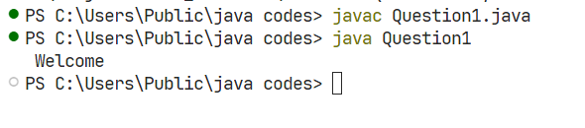

Q2 : Write a Java program to create multiple classes in a single java file and execute each class independently from JVM?

Solution :

class first

{

    public static void main(String args[]){

    System.out.println("hello I am the first class in java file");}

}

class second

{

    public static void main(String args[]){

    System.out.println("hello I am second class in java file");

}

}

class third

{

    public static void main(String args[]){

    System.out.println("hello I am third class in java file");

    }

}

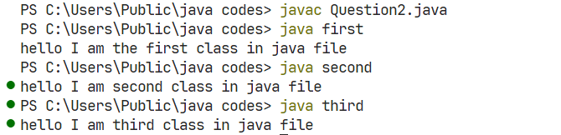

Q3 : Use code written in Q4, try to invoke overloaded main(), in the main method, from where program execution started?

Solution :

public class Question3 {

    public static void main(String[] args) {

        System.out.println("This is the standard main method with String[] args.");

        main(5);

        main(10, 20);

    }

    public static void main(int a) {

        System.out.println("This is the overloaded main method with an integer argument: " + a);

    }

    public static void main(int a, int b) {

        System.out.println("This is the overloaded main method with two integer arguments: " + a + " and " + b);

    }

}

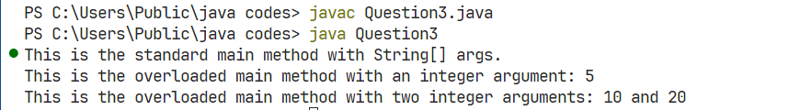

Q4 : Write a Java program to pass command line argument and display it on the screen?

Solution :

public class Question4 {

    public static void main(String[] args) {

        System.out.println("This is the main method");

    }

    static void main(int a) {

        System.out.println("This is the overloaded main method " + a);

    }

    static void main(int a,int b){

        System.out.println("This is the overloaded main method " + a + " " + b);

    }

    static void main(float a ,int b){

        System.out.println("This is the overloaded main method " + a + " " + b);

    }

}

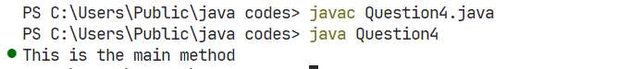

Q5 : Write a java program, accept following details from student: First name, last name, qualification, percentage, total marks.

Solution :

import java.util.Scanner;

public class Question9 {

    public static void main(String args[]){

        Scanner sc = new Scanner(System.in);

        System.out.println("Enter Total Marks, First Name, Last Name, Qualification, Percentage");

        int TotalMarks = sc.nextInt();

        String FirstName = sc.nextLine();

        String LastName = sc.nextLine();

        String Qualification = sc.nextLine();

        String Percentage = sc.nextLine();

        System.out.println(" First Name " + FirstName + " Last Name " + LastName + " Qualification " + Qualification + " Percentage " + Percentage + " Total Marks " + TotalMarks);

        sc.close();

    }

}

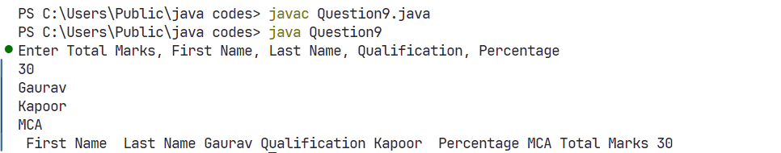

Q6 : Write a java program to check if number is “palindrome” or not.

Solution :

import java.util.Scanner;

public class Question12 {

    public static void main(String[] args) {

        Scanner sc = new Scanner(System.in);

        int OriginalNumber = sc.nextInt();

        int number = OriginalNumber;

        int ReverseNumber = 0;

        while(number!=0){

            int Remainder = number%10;

            ReverseNumber = ReverseNumber*10 + Remainder;

            number = number/10;

        }

        if(OriginalNumber == ReverseNumber){

            System.out.println("Palindrome");

    }else{

        System.out.println("Not Palindrome");

    }

    sc.close();

    }

}

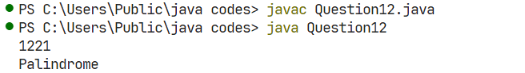

Q7 : Write java program to print table from 0 to accepted number, using loops and keyboard inputs.

import java.util.Scanner;

Solution :

public class Question13 {

    public static void main(String args[]){

        Scanner sc = new Scanner(System.in);

        int a  = sc.nextInt();

        for(int i = 1;i<=10;i++){

            System.out.println(a*i);

        }

        sc.close();

    }

}

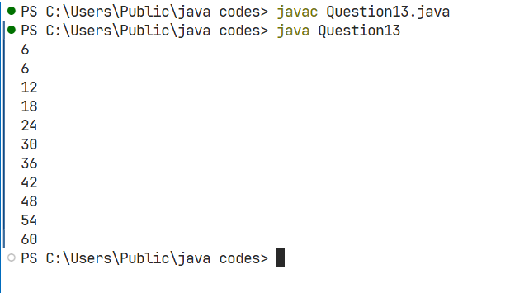

Q8 : Write a java program to create output like:

*

**

***

****  
*****

Solution :

public class Question15 {

    public static void main(String args[]){

        int n=5;

        for(int i = 0; i<n ; i++ ){

            System.out.println("");

            for(int j = 0; j<i ; j++)

                System.out.print("*");

        }

    }

}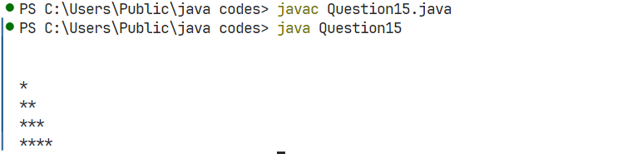

Q9 : Write a java program to display grade of students depends on marks. 100-80 [A],79-60[B],59-40[C], <40 [F]?

Solution :

import java.util.Scanner;

public class Question16 {

    public static void main(String[] args) {

        Scanner sc = new Scanner(System.in);

        System.out.println("Enter marks of student");

        int a  = sc.nextInt();

        if(a>80 && a<100){

            System.out.println("A");

        }else if(a>60 && a<79){

            System.out.println("B");

        }else if(a>40 && a<59){

            System.out.println("C");

        }else {

            System.out.println("F");

        }

        sc.close();

    }

}

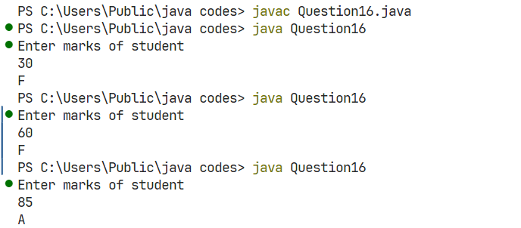

Q10 : Write a java program to check input no is part of Fibonacci series or not?

Solution :

import java.util.Scanner;

public class Question17 {

    public static void main(String[] args) {

        Scanner sc = new Scanner(System.in);

        System.out.println("Enter a number: ");

        int number = sc.nextInt();

        if(FibonacciSeries(number)==false){

            System.out.println("Number is not part of Fibonacci series");

        }else{

            System.out.println("Number is part of Fibonacci series");

        }

        sc.close();

    }

    static boolean FibonacciSeries(int number){

        int a = 0;

        int b = 1;

        int next = a + b;

        while(next < number){

            a = b;

            b = next;

            next = a + b;

        }

        return(next == number);

    }

}

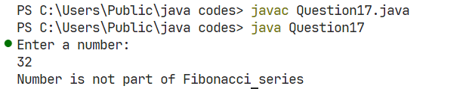

Q11 : Write a java program to Print Fibonacci series till that point.

Solution :

import java.util.Scanner;

public class Question18 {

    public static void main(String[] args) {

        Scanner sc = new Scanner(System.in);

        int number = sc.nextInt();

        Fibonacci(number);

        sc.close();

    }

    static void Fibonacci(int number){

        int a = 0;

        int b = 1;

        int next = a + b;

        while(next < number){

            System.out.print(" " + next);

            a = b;

            b = next;

            next = a+b;

        }

    }

}

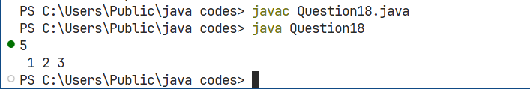

Q12 : Write a java program to print following output:

*

***

*****

*******

*****

***

*

Solution :

import java.util.Scanner;

public class Question21 {

    public static void main(String[] args) {

        Scanner sc = new Scanner (System.in);

        int number = sc.nextInt();

        for(int i=1; i<=number; i+=2){

            int j = i;

            while(j!=0){

                System.out.print("*");

                j--;

            }

            System.out.println();

        }

        for(int i=number-2; i>0; i-=2){

            int j = i;

            while(j!=0){

                System.out.print("*");

                j--;

            }

            System.out.println();

        }

        sc.close();

    }

}

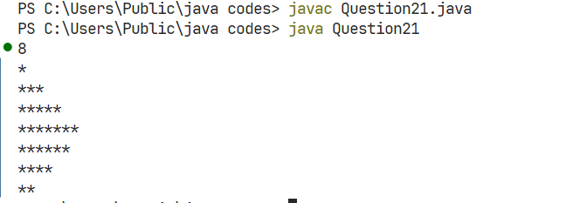

Q14 : Write a java program to accept 10 integer values from user, store them in array, arrange the array in ascending and descending order.

Solution :

import java.util.Arrays;

import java.util.Scanner;

public class Question22 {

    public static void main(String[] args) {

        Scanner sc = new Scanner(System.in);

        int arr[] = new int[4];

        for(int i =0; i<arr.length;i++){

            arr[i] = sc.nextInt();

        }

        System.out.println(Arrays.toString(arr));

        BubbleSorter(arr);

        sc.close();

    }

    static void BubbleSorter(int[] arr){

        int n = arr.length;

        for(int i=0;i<n-1;i++){

            for(int j=0;j<n-i-1;j++){

                if(arr[j]>arr[j+1]){

                    int temp = arr[j];

                    arr[j] = arr[j+1];

                    arr[j+1] = temp;

                }

            }

        }

        for(int i=0;i<n;i++){

            System.out.print(arr[i]+" ");

        }

    }

}

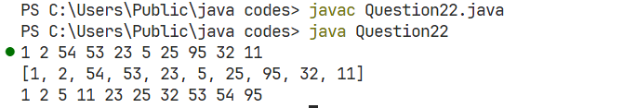

Q15 : Redo Q15 and Q21 with help of variable length multidimensional (Uneven/Irregular) Arrays.

Solution :

public class Question25 {

public static void main(String[] args) {

// Uneven array

int[][] unevenArray = new int[5][5];

// Display elements of uneven array

for (int i = 0; i < unevenArray.length; i++) {

for (int j = 0; j <= i; j++) {

System.out.print("*");

}

System.out.println();

}

}

}

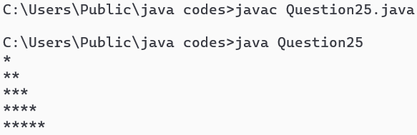

public class Question25 {

public static void main(String[] args) {

// Uneven array

int[][] unevenArray = new int[5][5];

// Display elements of uneven array

for (int i = 0; i < unevenArray.length; i++) {

for (int j = 0; j <= i; j++) {

System.out.print("*");

}

System.out.println();

}

for (int i = unevenArray.length-1; i > 0; i--){

for (int j = 0; j < i; j++) {

System.out.print("*");

}

System.out.println();

}

}

}

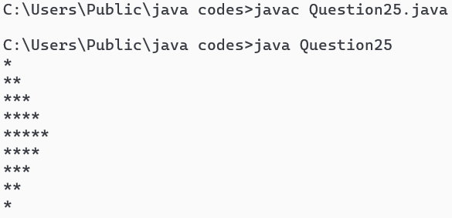

Q16 : Create a reference datatype array of class Student{name, Roll no} and save details of 3 students. Use methods form to accept and display data.

Solution :

import java.util.Scanner;

class Student {

String name;

int rollNo;

public void form() {

Scanner sc = new Scanner(System.in);

System.out.print("Enter Name: ");

name = sc.nextLine();

System.out.print("Enter Roll No: ");

rollNo = sc.nextInt();

}

public void display() {

System.out.println("Name: " + name);

System.out.println("Roll No: " + rollNo);

}

}

public class Question26 {

public static void main(String[] args) {

Student[] students = new Student[3];

for (int i = 0; i < 3; i++) {

students[i] = new Student();

System.out.println("Enter details for student " + (i+1));

students[i].form();

}

System.out.println("\nStudent Details:");

for (Student student : students) {

student.display();

}

}

}

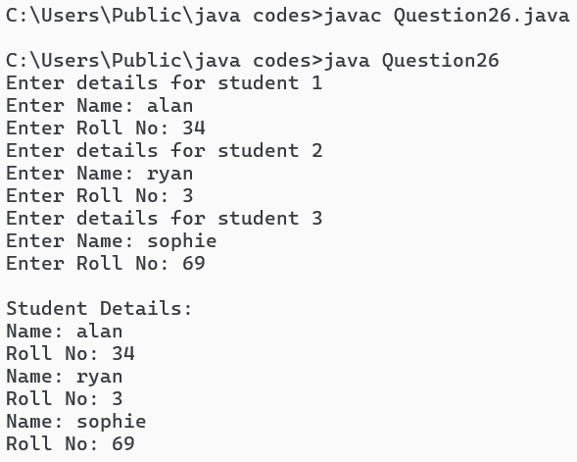

Q17 : Create a class called MyString : Declare two string type variables: str1 (“ Welcome to Java tutorial”) and str2(“Todays topic is String Handling in Java”). Perform following operations in this class:

1. Concatenate two strings
2. Covert str1 into lower case
3. Covert str2 into upper case
4. Are both equal to each other
5. Show the location of “J” in both str1 and str2
6. Replace “i” with “I” in both the strings
7. display “java” from str string
8. Display the 7th character in str1.
9. Convert str1 into string array

Solution :

public class Question27 {

String str1 = "Welcome to Java tutorial";

String str2 = "Todays topic is String Handling in Java";

public static void main(String[] args) {

Question27 obj = new Question27();

// a. Concatenate two strings

String concatenated = obj.str1 + " " + obj.str2;

System.out.println("Concatenated: " + concatenated);

// b. Convert str1 into lowercase

System.out.println("str1 in lowercase: " + obj.str1.toLowerCase());

// c. Convert str2 into uppercase

System.out.println("str2 in uppercase: " + obj.str2.toUpperCase());

// d. Are both equal to each other

System.out.println("Are both equal: " + obj.str1.equals(obj.str2));

// e. Show the location of “J” in both str1 and str2

System.out.println("Location of 'J' in str1: " + obj.str1.indexOf("J"));

System.out.println("Location of 'J' in str2: " + obj.str2.indexOf("J"));

// f. Replace “i” with “I” in both the strings

System.out.println("Replaced 'i' with 'I' in str1: " + obj.str1.replace('i', 'I'));

System.out.println("Replaced 'i' with 'I' in str2: " + obj.str2.replace('i', 'I'));

// g. Display “Java” from str1

System.out.println("Substring 'Java' from str1: " + obj.str1.substring(11, 15));

// h. Display the 7th character in str1

System.out.println("7th character in str1: " + obj.str1.charAt(6));

// i. Convert str1 into string array

String[] strArray = obj.str1.split(" ");

System.out.println("str1 as an array: ");

for (String s : strArray) {

System.out.println(s);

}

}

}

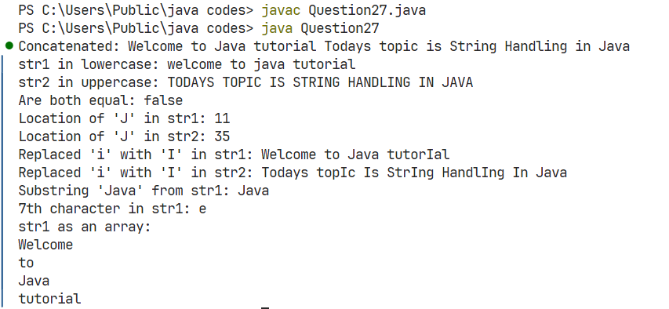

Q18 : Write a java programs to perform, Use classes and methods performs ( +,-,*,/,%). On instance variable dynamically accepted from user at runtime (Use Scanner Class to accept variable values).

Solution :

import java.util.Scanner;

class Calculator {

    int a,b;

    public int sum(){

        return a+b;

    }

    public int subtract(){

        return a-b;

    }

    public int multiply(){

        return a*b;

    }

    public int divide(){

        return a/b;

    }

    public int modulus(){

        return a%b;

    }

     public void getValues(){

        Scanner sc = new Scanner(System.in);

        a = sc.nextInt();

        System.out.println("Value of a: "+a);

        b = sc.nextInt();

        System.out.println("Value of b: "+b);

        sc.close();

    }

}

public class Question29{

    public static void main(String[] args) {

        Calculator calc = new Calculator();

        calc.getValues();

        System.out.println("Sum: " + calc.sum());

        System.out.println("Subtraction: " + calc.subtract());

        System.out.println("Multiplication: " + calc.multiply());

        System.out.println("Division: " + calc.divide());

        System.out.println("Modulus: " + calc.modulus());

    }

}

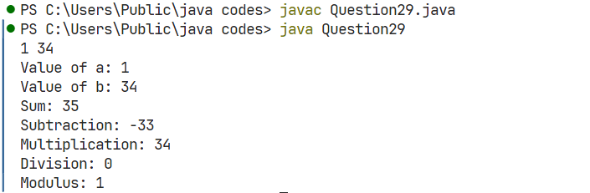

Q19 : Write a java program create class Person, use methods accept() [For accepting details] & display() [For displaying details]. Use main as starting point and call both the method. Accept following details: Name, Gender, Address, Contact no.

Solution :

import java.util.Scanner;

class Person {

private String name;

private String gender;

private String address;

private long contactNo;

public void accept() {

Scanner scanner = new Scanner(System.in);

System.out.print("Enter Name: ");

name = scanner.nextLine();

System.out.print("Enter Gender: ");

gender = scanner.nextLine();

System.out.print("Enter Address: ");

address = scanner.nextLine();

System.out.print("Enter Contact Number: ");

contactNo = scanner.nextLong();

}

public void display() {

System.out.println("Name: " + name);

System.out.println("Gender: " + gender);

System.out.println("Address: " + address);

System.out.println("Contact Number: " + contactNo);

}

}

public class Question30 {

public static void main(String[] args) {

Person person = new Person();

person.accept();

person.display();

}

}

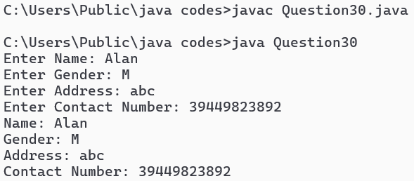

Q20 : Write a java program to convert primitive data type variable into equivalent wrapper class and vice versa.

Solution :

public class Question33 {

    public static void main(String[] args) {

        // Primitive types

        int primitiveInt = 42;

        double primitiveDouble = 3.14159;

        char primitiveChar = 'A';

        boolean primitiveBool = true;

        // Boxing: Primitive to Wrapper

        Integer wrappedInt = primitiveInt;

        Double wrappedDouble = primitiveDouble;

        Character wrappedChar = primitiveChar;

        Boolean wrappedBool = primitiveBool;

        System.out.println("Boxed Values:");

        System.out.println("Integer: " + wrappedInt);

        System.out.println("Double: " + wrappedDouble);

        System.out.println("Character: " + wrappedChar);

        System.out.println("Boolean: " + wrappedBool);

        // Unboxing: Wrapper to Primitive

        int unboxedInt = wrappedInt;

        double unboxedDouble = wrappedDouble;

        char unboxedChar = wrappedChar;

        boolean unboxedBool = wrappedBool;

        System.out.println("\nUnboxed Values:");

        System.out.println("int: " + unboxedInt);

        System.out.println("double: " + unboxedDouble);

        System.out.println("char: " + unboxedChar);

        System.out.println("boolean: " + unboxedBool);

    }

}

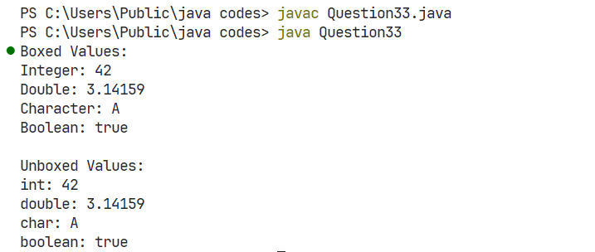

Q21 : Use the code written Student class [Data Member: First name, last name, qualification, percentage, total marks. Methods: Accept() and Display()] . Use inheritance and derive two classes: MCA and MBA from student class. MBA & MCA will have [Data Member: Stream and Duration, Member Method: Accept() and Display()). Display complete details of one MBA student and one MCA student. NOTE: use super keyword to invoke hidden members of base class.

Solution :

import java.util.Scanner;

class Student {

    String name;

    int rollNo;

    String qualification;

    void accept(Scanner sc) {

        System.out.println("Enter your name:");

        name = sc.nextLine();

        System.out.println("Enter your Roll No:");

        rollNo = sc.nextInt();

        sc.nextLine();

        System.out.println("Enter your Qualification:");

        qualification = sc.nextLine();

    }

    void display() {

        System.out.println("Name is: " + name);

        System.out.println("Roll No. is: " + rollNo);

        System.out.println("Qualification is: " + qualification);

    }

}

class MCA extends Student {

    String stream;

    int duration;

    void accept(Scanner sc) {

        super.accept(sc);

        System.out.println("Enter your Stream:");

        stream = sc.nextLine();

        System.out.println("Enter your Duration (in years):");

        duration = sc.nextInt();

        sc.nextLine();

    }

    void display() {

        super.display();

        System.out.println("Your Stream is: " + stream);

        System.out.println("Your Duration is: " + duration + " years");

    }

}

class MBA extends Student {

    String stream;

    int duration;

    void accept(Scanner sc) {

        super.accept(sc);

        System.out.println("Enter your Stream:");

        stream = sc.nextLine();

        System.out.println("Enter your Duration (in years):");

        duration = sc.nextInt();

        sc.nextLine();

    }

    void display() {

        super.display();

        System.out.println("Your Stream is: " + stream);

        System.out.println("Your Duration is: " + duration + " years");

    }

}

public class Question35 {

    public static void main(String[] args) {

        Scanner sc = new Scanner(System.in);

        MCA mcaStudent = new MCA();

        System.out.println("Enter details for MCA:");

        mcaStudent.accept(sc);

        System.out.println("Information of MCA Student:");

        mcaStudent.display();

        MBA mbaStudent = new MBA();

        System.out.println("Enter details for MBA:");

        mbaStudent.accept(sc);

        System.out.println("Information of MBA Student:");

        mbaStudent.display();

        sc.close();

    }

}

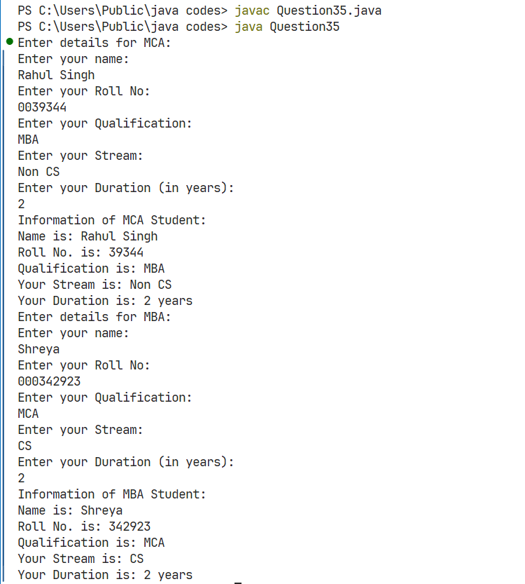

Q22 : Create a class shape with following structural details: data member: dimensions, Method[only definition]: cal_area() and cal_perimeter(). Use above mentioned structure and calculate area and perimeter of square and circle.

Solution :

// Abstract class Shape

abstract class Shape {

    double dimensions; // For Square: side; For Circle: radius

  // Abstract methods

    abstract void cal_area();

    abstract void cal_perimeter();

}

// Class Square extending Shape

class Square extends Shape {

    // Constructor

    public Square(double side) {

        this.dimensions = side;

    }

    @Override

    void cal_area() {

        double area = dimensions * dimensions;

        System.out.println("Area of Square: " + area);

    }

    @Override

    void cal_perimeter() {

        double perimeter = 4 * dimensions;

        System.out.println("Perimeter of Square: " + perimeter);

    }

}

// Class Circle extending Shape

class Circle extends Shape {

    // Constructor

    public Circle(double radius) {

        this.dimensions = radius;

    }

    @Override

    void cal_area() {

        double area = Math.PI * dimensions * dimensions;

        System.out.println("Area of Circle: " + area);

    }

    @Override

    void cal_perimeter() {

        double perimeter = 2 * Math.PI * dimensions;

        System.out.println("Perimeter (Circumference) of Circle: " + perimeter);

    }

}

public class Question36 {

    public static void main(String[] args) {

        // Create a Square with side 5

        Square square = new Square(5);

        square.cal_area();

        square.cal_perimeter();

        System.out.println();

        // Create a Circle with radius 3

        Circle circle = new Circle(3);

        circle.cal_area();

        circle.cal_perimeter();

    }

}

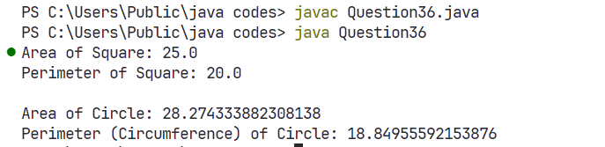

Q23 : Write a java program, create abstract class IP that contains 4 methods: 2 methods are abstract & 2 methods are defined. (exentnal_Exam, internal_Exam, Assignment, performance_Evaluation). Inherit this class in a class called JIMS that contains one more extra method: talent_Hunt(). Create an object of JIMS class and call all 4 methods.

Solution :

abstract class IP {

abstract void external_Exam();

abstract void internal_Exam();

void Assignment() {

System.out.println("Assignment Completed");

}

void performance_Evaluation() {

System.out.println("Performance Evaluation Done");

}

}

class JIMS extends IP {

void talent_Hunt() {

System.out.println("Talent Hunt Participation");

}

@Override

void external_Exam() {

System.out.println("External Exam Passed");

}

@Override

void internal_Exam() {

System.out.println("Internal Exam Cleared");

}

public static void main(String[] args) {

JIMS jimsStudent = new JIMS();

jimsStudent.external_Exam();

jimsStudent.internal_Exam();

jimsStudent.Assignment();

jimsStudent.performance_Evaluation();

jimsStudent.talent_Hunt();

}

}

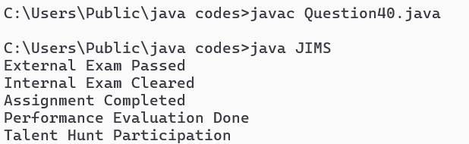

Q24 : In extension of Q9 of this file, please raise a user defined checked Exception, if percentage is less than 0 or more than 100.

Solution :

import java.util.Scanner;

// User-defined checked exception

class InvalidPercentageException extends Exception {

public InvalidPercentageException(String message) {

super(message);

}

}

public class Question45 {

// Method to accept student details and validate the percentage

public static void acceptStudentDetails() throws InvalidPercentageException {

Scanner sc = new Scanner(System.in);

// Accepting student details

System.out.print("Enter First Name: ");

String firstName = sc.nextLine();

System.out.print("Enter Last Name: ");

String lastName = sc.nextLine();

System.out.print("Enter Qualification: ");

String qualification = sc.nextLine();

System.out.print("Enter Percentage: ");

double percentage = sc.nextDouble();

System.out.print("Enter Total Marks: ");

int totalMarks = sc.nextInt();

// Validating the percentage

if (percentage < 0 || percentage > 100) {

throw new InvalidPercentageException("Invalid percentage! It should be between 0 and 100.");

}

// Displaying the student details

System.out.println("\nStudent Details:");

System.out.println("First Name: " + firstName);

System.out.println("Last Name: " + lastName);

System.out.println("Qualification: " + qualification);

System.out.println("Percentage: " + percentage);

System.out.println("Total Marks: " + totalMarks);

}

public static void main(String[] args) {

try {

// Calling the method to accept student details

acceptStudentDetails();

} catch (InvalidPercentageException e) {

// Handling the exception and displaying the error message

System.out.println(e.getMessage());

}

}

}

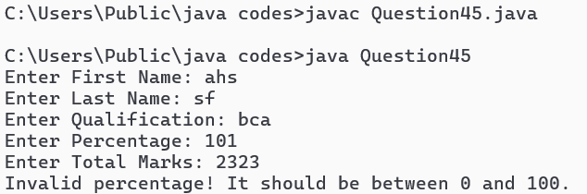

Q25 : In extension to Q30, Accept one more detail from student, “EmailID”. Raise an exception if email Id entered by user does not contain ‘@’ character. Handle the exception in an appropriate manner.

Solution :

import java.util.Scanner;

class Person {

    private String name, gender, address, contactNo, emailId;

    public void accept() throws InvalidEmailException{

        Scanner scanner = new Scanner(System.in);

        System.out.print("Enter Name: ");

        name = scanner.nextLine();

        System.out.print("Enter Gender: ");

        gender = scanner.nextLine();

        System.out.print("Enter Address: ");

        address = scanner.nextLine();

        System.out.print("Enter Contact Number: ");

        contactNo = scanner.nextLine();

        System.out.print("Enter Email ID: ");

        emailId = scanner.nextLine();

        // Validate email ID

        if (!emailId.contains("@")) {

                throw new InvalidEmailException("Invalid Email ID: Email ID must contain '@'");

            }

        }

    public void display() {

        System.out.println("Name: " + name);

        System.out.println("Gender: " + gender);

        System.out.println("Address: " + address);

        System.out.println("Contact Number: " + contactNo);

        System.out.println("Email ID: " + emailId);

    }

}

class InvalidEmailException extends Exception {

    public InvalidEmailException(String message) {

        super(message);

    }

}

public class Question48 {

    public static void main(String[] args) {

        Person person = new Person();

        try {

            person.accept();

           } catch (InvalidEmailException e) {

            System.out.println(e.getMessage());

        }

        person.display();

    }

}

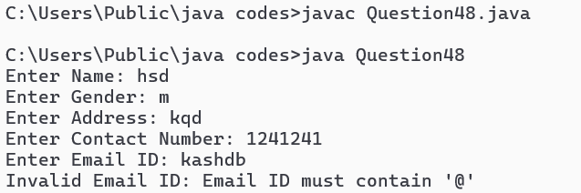

Q26 : Write a java program extract details of main thread, change name and priority of main thread.

Solution :

public class Question49 extends Thread {

    public static void main(String args[]){

        Thread t = Thread.currentThread();

        System.out.println("Thread name "+t.getName());

        System.out.println("Thread Priority "+t.getPriority());

        System.out.println("Thread state "+t.getState());

        System.out.println("Thread group "+t.getThreadGroup());

        t.setName("thread1");

        t.setPriority(2);

        System.out.println("New thread name "+t.getName());

        System.out.println("New thread priority "+t.getPriority());

    }

}

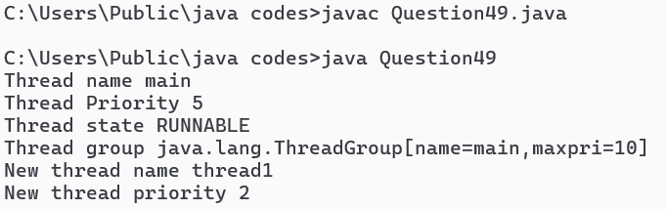

Q27 : Write a java program to create multiple (2 threads) main thread will print A….Z and child thread will print 1….50 [Use thread class]

Solution :

public class Question50 extends Thread{

Question50(){

start();

}

public void run(){

for(int i=0;i<=50;i++)

System.out.println("Child thread "+i);

}

public static void main(String []args){

Question50 m=new Question50();

for(char ch='A';ch<='Z';ch++)

System.out.println("Parent thread "+ch);

}

}

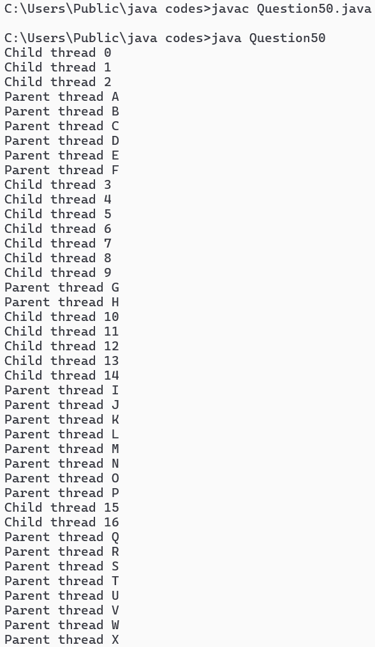 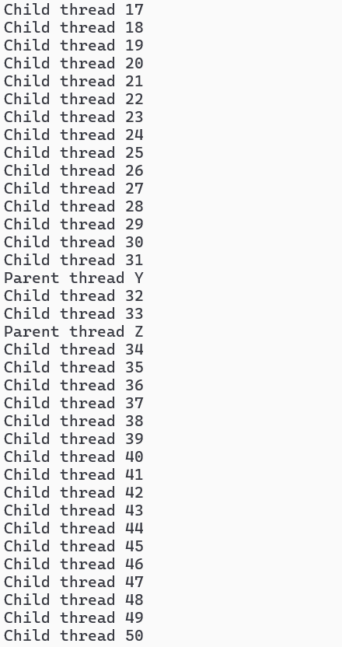

Q28 : Write a java program to print IP address of local machine and IP address of [www.facebook.com](http://www.facebook.com).

Solution :

import java.net.*;

public class Question53{

public static void main(String[] args) throws UnknownHostException {

InetAddress fbAddress = InetAddress.getByName("www.facebook.com");

InetAddress localhost1 = InetAddress.getLocalHost();

System.out.println("IP address of www.facebook.com is: "+fbAddress);

System.out.println("Local machine IP address is: "+localhost1);

    }

}

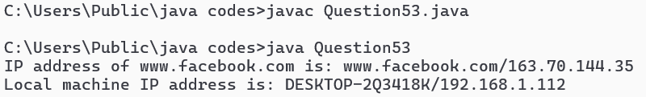

Q29 : Handle appropriate events in both Q51 an . Generate required user interactions on both form.

Solution :

import java.io.*; // Question 58

public class FileReadWrite {

    public static void main(String[] args) {

        String data = "This is a test message.";

        // Write data to file

        try (FileWriter writer = new FileWriter("output.txt")) {

            writer.write(data);

            System.out.println("Data written to file.");

        } catch (IOException e) {

            e.printStackTrace();

        }

        // Read data from file

        try (BufferedReader reader = new BufferedReader(new FileReader("output.txt"))) {

            String line;

            while ((line = reader.readLine()) != null) {

                System.out.println("Read from file: " + line);

            }

        } catch (IOException e) {

            e.printStackTrace();

        }

    }

}

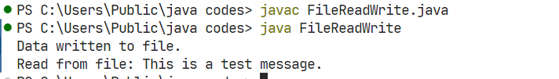

Q30 : Write a java program read data (byte and character) from buffer.

Solution :

import java.util.*; /

public class CollectionsDemo {

    public static void main(String[] args) {

        List<String> list = new ArrayList<>(Arrays.asList("Apple", "Banana", "Cherry"));

        System.out.println("List: " + list);

        // Queue

        Queue<Integer> queue = new LinkedList<>(Arrays.asList(1, 2, 3));

        System.out.println("Queue: " + queue);

        // Set

        Set<String> set = new HashSet<>(Arrays.asList("Red", "Blue", "Green"));

        System.out.println("Set: " + set);

        // Map

        Map<Integer, String> map = new HashMap<>();

        map.put(1, "One");

        map.put(2, "Two");

        map.put(3, "Three");

        System.out.println("Map: " + map);

    }

}

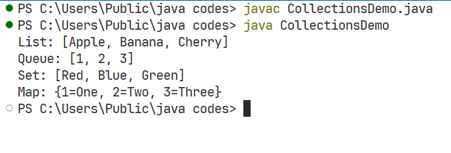

Q31 : Make required assumptions, show creation and implementation of functional interfaces and lambda expression.

Solution :

//functional interface

interface Sayable {

    String say();

}

public class Question64 {

    public static void main(String[] args) {

        //lambda expression

        Sayable s = () -> { return "Hello, World!"; };

        System.out.println(s.say());

    }

}

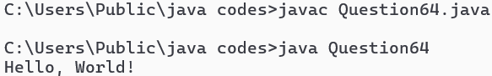

Q32 : Use GUI and create a login window where users can log in by verifying details from the database.

Solution :

import java.awt.*;

import java.awt.event.ActionEvent;

import java.awt.event.ActionListener;

import java.sql.*;

import javax.swing.*;

public class Question68 extends JFrame implements ActionListener {

    private JTextField usernameField;

    private JPasswordField passwordField;

    private JButton loginButton;

    public Question68() {

        setTitle("Login Window");

        setSize(300, 200);

        setDefaultCloseOperation(JFrame.EXIT_ON_CLOSE);

        setLayout(new GridLayout(3, 2));

        add(new JLabel("Username:"));

        usernameField = new JTextField(20);

        add(usernameField);

        add(new JLabel("Password:"));

        passwordField = new JPasswordField(20);

        add(passwordField);

        loginButton = new JButton("Login");

        loginButton.addActionListener(this);

        add(loginButton);

        setVisible(true);

    }

    @Override

    public void actionPerformed(ActionEvent e) {

        String username = usernameField.getText();

        String password = new String(passwordField.getPassword());

        try {

            // Replace with your database connection details

            Connection conn = DriverManager.getConnection("jdbc:mysql://localhost:3306/mydatabase", "user", "password");

            PreparedStatement stmt = conn.prepareStatement("SELECT * FROM users WHERE username = ? AND password = ?");

            stmt.setString(1, username);

            stmt.setString(2, password);

            ResultSet rs = stmt.executeQuery();

            if (rs.next()) {

                JOptionPane.showMessageDialog(this, "Login Successful!");

                // Proceed to the next screen or perform other actions

            } else {

                JOptionPane.showMessageDialog(this, "Invalid username or password");

            }

            rs.close();

            stmt.close();

            conn.close();

        } catch (SQLException ex) {

            ex.printStackTrace();

            JOptionPane.showMessageDialog(this, "Error: " + ex.getMessage());

        }

    }

    public static void main(String[] args) {

        new Question68();

    }

}

